Abstract- EMOTIV EPOC
For over a millennium, man has dreamed of the ability to move or control objects through the power of thought. When we look at the communication between the people it is far more interesting because we take into account far more than what is explicitly expressed. We look at the facial expressions, body language and we intuit emotions and feelings into our dialog with the other person. Understanding and predicting the behavior of decision makers when choosing among discrete goods has been one of the most fruitful areas of applied research over the last thirty years.
From Electroencephalogram (EEG) of people we understand how the brain responds while undertaking choices designed to elicit the subjects’ preferences. A brain computer interface (BCI) represented by the commercial Emotiv EPOC wireless EEG headset is utilized to capture the associated brain activity.
An Australian neural engineering company Emotiv Systems has developed a brain-computer interface (BCI) known as Emotiv EPOC which is a headset based on electroencephalography (EEG) technology. Far from the complicated controllers of other systems, the controller the Emotiv EPOC uses is one we have been familiar with all our lives i.e. our brain. The headset actually picks up on our brain waves and that are converted into commands. These brain waves can tell the system what we want to do in our virtual reality. That means mere thoughts can translate into actions. In other words, you think "lift," and a virtual rock actually levitates on the screen.
EPOC isn't an acronym; it's a play on the word "epoch," which refers to a time of momentous technological development or beginning of important era.
Emotive EPOC is the first high-fidelity brain computer interface that reads and interprets both conscious and non-conscious thoughts as well as facial expressions, body language and emotions. The range of the system spans 30 different expressions, emotions and actions. The emotion of boredom, the facial expression of smiling and the thought of pulling are just a few examples of things the system picks up on and translates to your avatar's actions on the screen in the game.
The Emotiv Epoc is a very powerful tool in the world of mind-controlled processes. It is easy to use and wireless. The portability provides a better usage of the headset. The technology used to detect the motion as well as human expressions is very effective.
1. INTRODUCTION

The Emotiv EPOC headset is a cheap and easy-to-use mass-market EEG recording device. Targeted at video gamers, Emotiv promises to add a new dimension to the gaming experience by providing brain-computer interface (BCI) functionalities. Emotiv’s simplicity has also attracted the interest of neuroscientists. Unlike traditional EEG setups and functional MRI, the Emotiv headset offers the possibility of running inexpensive experiments from the comfort of one’s laptop. In the interest of exploiting these capabilities, I developed Experimenter, an application which can be used to collect and process EEG data within a configurable experimental framework. Based on the latest developments in neuro-technology, Emotiv presents a revolutionary personal interface for human computer interaction. Emotiv EPOC is a high resolution, multi-channel, wireless neuroheadset. The EPOC uses a set of 14 sensors plus 2 references to tune into electric signals produced by the brain to detect the user’s thoughts, feelings and expressions in real time. The EPOC connects wirelessly to PCs running Windows, Linux, or MAC OS X.

1.1 EEG
Electroencephalography (EEG) is a nonintrusive means of recording brain activity. An array of electrodes attached to the scalp via conductive gel or paste is used to detect electrical activity produced by neurons firing within the brain. The resulting waveforms, popularly referred to as “brain waves”, can be used to diagnose epilepsy and some other abnormal brain conditions. EEG is also of interest to researchers because it can be used as part of an experiment to study the neurological activity following the presentation of specific stimuli or under specific conditions.

1.2 The Emotiv Headset
The Emotiv headset is an attempt to bring EEG capabilities to the masses. At $299.00 ($750.00 for the research SDK), the headset is relatively affordable. More importantly, the headset’s fixed sensor-array makes it easy to use and highly portable. Since it connects wirelessly to any PC via a USB dongle, the user maintains a full range of motion. Instead of gel or paste, Emotiv simply requires that the user wet its foam-tipped sensors with contact lens solution prior to each use. The headset does pay a price, however, for such simplicity: there are only 14 channels, less than ¼ the number used in many research setups(Newman & Norman, 2010)(Parra, Spence, Gerson, & Sajda, 2005). The data sample rate, at 128Hz, is also far lower than in more powerful setups which sample at up to 1000Hz(Newman & Norman, 2010)(Parra, Spence, Gerson, & Sajda, 2005). The arrangement of the electrodes approximates the popular 10-20 positioning scheme(Emotiv, 2010).
Although the headset is an EEG device, most developers using the device do not have access to the raw EEG data stream (this is available only in the research edition)(Emotiv, 2009). Instead, the Emotiv APIs exposed by the standard SDK consist of three event-based classification “suites.” The Expressiv^{ity} suite tries to detect the wearer’s facial expression, the Affectiv^{ity} suite tries to detect the wearer’s mood, and the CognitivTM suite tries to detect occurrences of user-defined cognitive events(Emotiv, 2010).
Emotiv’s online application store offers a number of innovative EEG-powered programs built on these suites. EmoLens tags users’ photos based on their emotions when viewing them. NeuroKey acts as a virtual keyboard for the disabled which can be interfaced with via both facial expressions and trained cognitive actions. The Spirit Mountain game promises a true fantasy experience by allowing the user to manipulate a virtual world with his or her mind. The headset has also become a part of several interesting side projects, such as acting as a controller for a superman-style human flight simulator and a robotic car (Solon, 2011)(Squatriglia, 2011).
Customer reviews of the device, however, are highly mixed. The facial expression-detection system is said to work very well, but unsurprisingly what reviewers really care about is the headset’s promise of mind-reading capabilities. In this area, most reviewers seem to feel that the Emotiv’s thought detection algorithms are at best unreliable, making it nearly impossible to play even simple games like Pong (Root, 2011)(Dakan, 2010). My own experience with Emotiv’sfree Spirit Mountain demo game seemed to confirm these reviewers’ experiences. In the game, the player’s first task is to drive away evil spirits by clenching his or her teeth and growling. This works perfectly. The next set of tasks require the user to train Emotiv to recognize two distinct thought patterns: lift and pull. After training, I could never seem to trigger lifts or pulls with conscious thoughts. More frustratingly, Emotiv often detected lifts and pulls when my attention was focused elsewhere! However, some sources suggest that more practice may help eliminate such difficulties (Emotiv, 2010).

2.Brain computer Interface
(BCI)

2.1 overview
Science and technology of devices and systems responding to neural and/ or cognitive processes, which enable their users who may have neural pathways that have been damaged by, amputation ,trauma or diseases to:
- Control their environment through re-animation of paralyzed limbs
- Control robotic devices
- Control computer devices
A brain–computer interface (BCI), sometimes called a direct neural interface or a brain–machine interface, is a direct communication pathway between a brain and an external device. BCIs are often aimed at assisting, augmenting or repairing human cognitive or sensory-motor functions
2.2 History
Research on BCIs began in the 1970s at the University of California Los Angeles (UCLA) under a grant from the National Science Foundation, followed by a contract from DARPA. The papers published after this research also mark the first appearance of the expression brain–computer interface in scientific literature.
2.3 Working
One of the most exciting areas of BCI research is the development of devices that can be controlled by thoughts. If you think a remote control is convenient, imagine changing channels with your mind.
However, there's a bigger picture devices that would allow severely disabled people to function independently.
For a quadriplegic, something as basic as controlling a computer cursor via mental commands would represent a revolutionary improvement in quality of life. But how do we turn those tiny voltage measurements into the movement of a robotic arm?

Early research used monkeys with implanted electrodes. The monkeys used a joystick to control a robotic arm. Scientists measured the signals coming from the electrodes. Eventually, they changed the controls so that the robotic arm was being controlled only by the signals coming from the electrodes, not the joystick.
Consider a person who cannot move his or her left hand physically. A robotic arm can be attached to the body of the person. A pair of electrodes is implanted in the body of the person, 1 electrode in each arm as shown in figure 2.1.

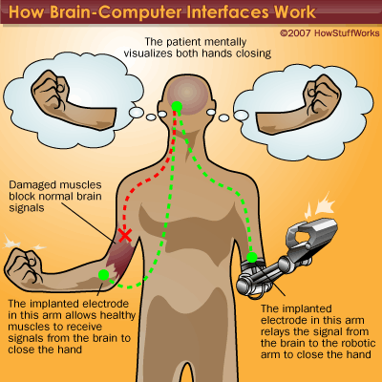
Fig. The working of a brain-computer interface using a robotic arm

A more difficult task is interpreting the brain signals for movement of the person. With a task like that, the subject must "train" to use the device. With an EEG or implant in place, the subject would visualize closing his or her right hand. After many trials, the software can learn the signals associated with the thought of hand-closing.
Software connected to a robotic hand is programmed to receive the "close hand" signal and interpret it to mean that the robotic hand should close. At that point, when the subject thinks about closing the hand, the signals are sent and the robotic hand closes.
A similar method is used to manipulate a computer cursor, with the subject thinking about forward, left, right and back movements of the cursor. With enough practice, users can gain enough control over a cursor to draw a circle, access computer programs and control a TV.
2.4 Applications

2.4.1 Medical Field:
Once the basic mechanism of converting thoughts to computerized or robotic action is perfected, the potential uses for the technology are almost limitless. Instead of a robotic hand, disabled users could have robotic braces attached to their own limbs, allowing them to move and directly interact with the environment. This could even be accomplished without the "robotic" part of the device. Signals could be sent to the appropriate motor control nerves in the hands, bypassing a damaged section of the spinal cord and allowing actual movement of the subject's own hands.

2.4.2 Computer Field:
Some of the applications of this technology are the ability to control a video game by thought.

2.5 BCI Drawbacks

Although we already understand the basic principles behind BCIs, they don't work perfectly. There are several reasons for this.

- The brain is incredibly complex. There are about 100 billion neurons in a human brain. Each neuron is constantly sending and receiving signals through a complex web of connections. There are chemical processes involved as well, which EEGs can't pick up on.
- The signal is weak and prone to interference. EEGs measure tiny voltage potentials. Something as simple as the blinking eyelids of the subject can generate much stronger signals. Now reading brain signals is like listening to a bad phone connection.
- The equipment is less than portable. It's far better than it used to be early systems were hardwired to massive mainframe computers. But some BCIs still require a wired connection to the equipment, and those that are wireless require the subject to carry a computer that can weigh around 10 pounds. Like all technology, this will surely become lighter and more wireless in the future.
3. Electroencephalogram
(EEG)
3.1 overview
The literature on emotion recognisation reveals the emotions can be extracted from physiological signal signals like heart rate, skin conductance and brain signal i.e., the electroencephalogram(EEG) along the well known EEG frequency bands well-known EEG frequency bands such as delta (0.5–4 Hz), theta(4–7 Hz), alpha (8–12 Hz), beta (13–30 Hz), and gamma (30–40 Hz).
In general, only a limited number of studies gathering both neural(cognitive and emotion) data and preference data have been conducted as this is a newly emerging area. As seen, many of the available studies focus on the brain activities elicited during the observation of TV commercials (Astolfi et al., 2008; Custodio,2010) and not on the actual preferences. However, it is obvious that the choices people make everyday are affected by unconscious processes in the brain indicating the importance of this field of research. To begin linking these two streams together, the changes in the power spectrum of well-known EEG frequency bands i.e., alpha,beta,gamma,theta , beta needs to be examined with regard to the changes in preferences during decision making. Thus, as a first step toward understanding the role of EEG as a measure of emotional and cognitive response in decision making.
3.2 Need of EEG
we probably know that our brain is home to billions of neurons, which are nerve cells. Using electrical impulses, they send messages to and through each other. Whenever your brain is working (and that means always, even during sleep), all these messages firing from neuron to neuron amount to an electrical current.
Although the brain continues to be an enigmatic subject of study, scientists have known about brain waves, which are a map of the electrical current firing from neuron to neuron, for a while. British physician Richard Caton first noticed the brain's current in 1875. By 1924, German neurologist Hans Berger found a way to read the current by developing what's known as an electroencephalograph. This kind of machine produces a graph measurement of brain waves, known as an electroencephalogram (EEG).
The system involves hooking up several pairs of electrodes on a patient's head. These electrodes are disks that conduct electrical activity, capture it from the brain and convey it out through a wire to a machine that amplifies the signal. Scientists attach electrodes in pairs on the head because they're measuring the difference in voltage between the pair. Soon after starting his research, Berger noticed that the electrical activity of brain waves correlated to a person's state of mind.
A Fig. 3.2 a patient with the EEG
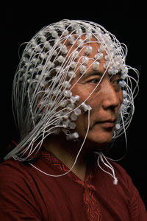
As we mentioned, your brain fires out this electrical current even when you're sleeping. Your brain waves are usually slowest during sleep. However, slow is relative. In deep sleep, the brain transmits delta waves, which fire one to four times per second. In light sleep, theta waves fire about four to seven times per second. Alpha waves, which we emit when we're in a relaxed, conscious state, come next at about seven to 13 pulses per second. Lastly, beta waves, which reflect a very excited or stressed mind, fire fastest at 13 to 40 times per second. Your brain doesn't emit just one kind of wave at one time; rather, it emits multiple kinds of waves simultaneously. Nevertheless, one kind of wave can dominate in a given moment.
Today, doctors are able to use EEG tests for a variety of applications, such as diagnosing epilepsy as well as other seizure disorders. The test is appropriate for diagnosing epilepsy because the everyday brain wave patterns of patients with epilepsy tend to be abnormal. EEG tests can also reveal sleep disorders, tumors and the effects of a head injury or determine whether a coma patient has become brain dead.

The EPOC is a low cost Human–Computer Interface (HCI) comprised of 14 channels of EEG data and a gyroscope measure for 2 dimensional controls (www.emotiv.com). The electrodes are located at the positions AF3, F7, F3, FC5, T7, P7, O1, O2, P8, T8, FC6, F4, F8, AF4 according to the International 10–20 system as shown in Fig. 4 (Campbell, Choudhury, Mukerjee, Rabbi, & Raizada, 2010)and Fig. 5. Two electrodes located just above the participants ears (CMS/DRL) are used as references (one for the left and the other for the right hemisphere of the head). The EPOC internally samples at a frequency of 2048 Hz which then gets down-sampled to 128 Hz sampling frequency per channel, with the data then sent to a computer via Bluetooth. It utilizes a proprietary USB dongle to communicate using the 2.4 GHz band. Prior to use, all felt pads on top of the sensors have to be moistened with a saline solution. The Emotiv Software Development Kit (SDK) provides a packet count functionality to ensure no data is lost, a writable marker trace to ease single trial segmentation tasks, and real-time sensor contact display to ensure quality of measurements (Anderson et al., 2011; Bobrov et al., 2011). The effectiveness of the EPOC headset as a real-time brain EEG scanner was demonstrated in a number of recent publications,1 including a demonstration at the wellknown neural information processing conference.
Both of the EPOC and eye tracker were made to start at the same time by means of synchronization software written in Visual Basic to start both of these modules together. After the data collection step, all of the collected data was transferred to Matlab .

Fig. Represents the basic electrode structure

Pointed arrows represents the alpha rhythm
Likewise whenever we operate the epoc headset with help of EEG the waves are measured with help of some standard frequency as mentioned earlier. Every action represents different waves and pattern which can be mapped with help of epoc headset but here EEG plays vital role of actually representation of the every action and thought .

4. Gyroscope
4.1 Overview
A gyroscope is a device for measuring or maintaining orientation. A mechanical gyroscope is essentially a spinning wheel or disk whose axle is free to take any orientation. This orientation changes much less in response to a given external torque than it would without the large angular momentum associated with the gyroscope's high rate of spin.
4.2 History
The first ever Gyroscope was made by a German scientist Johann Bohnenberger in 1817.
4.3 Classification
1) Mechanical Gyroscope:
It uses an electric motor to spin a small disc or flywheel that can pivot on one axis and has springs to return it to center.
2) Piezoelectric Gyroscope:
It uses a quickly vibrating crystal. As the crystal vibrates, an applied rotational force will cause disturbances in its wobble which creates a small, but measurable electric current proportional to the rate at which the gyro is rotated.
3) Micro Electric-Mechanical System Gyroscope (MEM):
MEMS are molecule sized machines that are fabricated on top of a piece of silicon, along with the electronics to interface to them.
They vibrate at a high rate. As the gyro rotates, so does the displacement of the mass and the
Signal generated by the gyroscope. The figure 4.1 shows an Electric-Mechanical System Gyroscope (MEM).
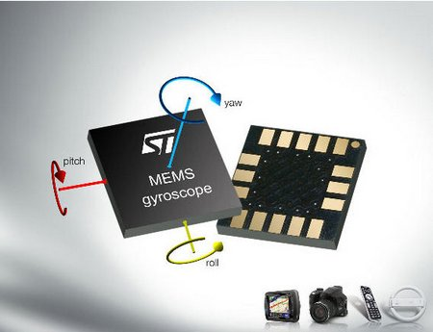
Fig.4.1 MEMS Gyroscope [2]

4.4 Applications
Gyros or gyroscopes are used in everything from full computer mice to the navigation system on the space shuttle to RC helicopters.
MEM gyroscopes may be used in various military, navigation, automotive, and space applications. Space applications include satellite stabilization in which MEM technology can significantly reduce the cost, power, and weight of the presently used gyroscopic systems. Automotive air bag deployment, ride control, and anti-lock brake systems provide other applications for MEM gyroscopes and/or sensor. Military applications include low drift gyroscopes.

5. Emotive EPOC Headset
5.1 System Configuration
The Emotiv EPOC headset uses seven pairs of electrodes that read our thoughts and play the video game provided by Emotive Systems with the headset as shown in figure 5.1. The game is created using the Emotive Development Kit (EDK).
Emotiv Systems has applied this technology to the gaming world so everyone can experience it. Emotive Epoc is the first high-fidelity brain computer interface (BCI) that reads and interprets both conscious and nonconscious thoughts as well as facial expressions, body language and emotions. The range of the system spans 30 different expressions, emotions and actions. The emotion of boredom, the facial expression of smiling and the thought of pulling are just a few examples of things the system picks up on and translates to your avatar's actions on the screen in the game.
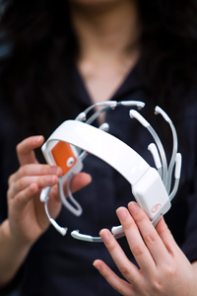
Fig. 5.1 The Emotive Epoc Headset [4]
The EPOC headset incorporates 14 extensions of electrodes (seven pairs), mostly centered around the front of the scalp. But rather than using the wires of traditional EEG tests, the headset is completely wireless, allowing the player free, natural movement with a battery life of 12 hours. To go along with that, the headset also includes a two-axis gyroscope for measuring head rotation. It allows the player's head motions to control the camera or curser.
In a doctor's office, it might take a sticky gel to keep the electrodes in place, but the EPOC headset fits on our head similar to the way headphones do. The system costs significantly less, too -- instead of the tens or hundreds of thousands of dollars that EEG machines usually cost, the EPOC costs only a few hundred.

5.2 Working

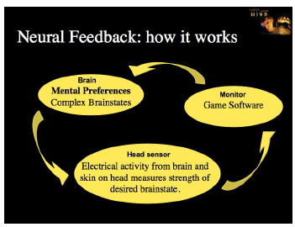
Fig. 5.2 Science behind Emotiv Epoc [3]

Emotions and non-conscious thoughts can be detected before we are even aware. Multichannel Brain-Computer Interface allows traditional input of conscious control while providing a feedback loop based on user perception as shown in figure 5.2.
But all people seem to have unique patterns of brain waves. So how the Emotiv EPOC can read our brain waves?
The headset must first be trained to recognize what kind of thought pattern equates to a certain action. As we have seen before the electrodes provided on the headset capture the brain waves. To get the correct expression or feeling, Emotive has created its detection suites which are based on the way the humans interact with each other. These are three different software programs used to detect the emotion or expression. The Emotive Development Kit (EDK) connects the headset to these programs.
The three categories of detection:
1) Expressive:
It is for understanding facial expressions. Expressions are detected by EEG sensors. It allows your expression in a virtual environment to become intuitive, lifelike.
2) Affectiv:
It is for understanding emotional experience . It can adjust the game dynamically to our personal experience. Music, intensity of music, colors in the game can change based on our emotional experience.
3) Cognitiv:
It is for fulfilling mankind’s longest and largest fantasies. It allows us to control the object just by thinking about it.
One more kind of input can be measured by the Emotive Epoc i.e. head rotation. The angular velocity of the head is measured by gyroscopes.
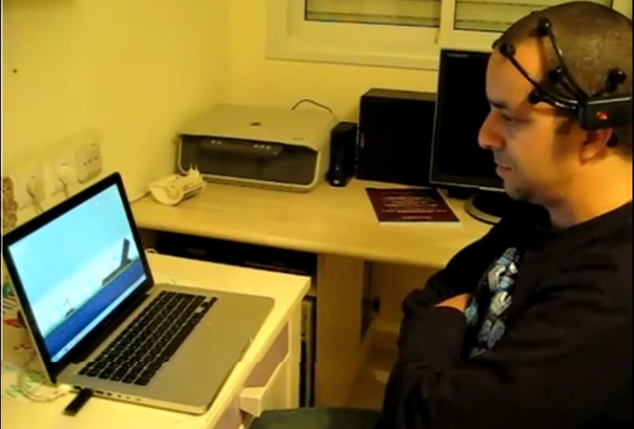
5.3 Related work
For over a century, EEG devices have been used mainly in medical application fields . In the field of neuroscience, EEG systems are employed for recording the electrical activity of the brain in order to detect abnormal activity, for example to diagnose epilepsy. More recently, Brain-Computer Interface (BCI) research has focused on EEG-based systems, as these appear to be a feasible alternative for providing interaction possibilities, e.g., for physically handicapped people and people with motoric disorders . In , Grimes et al. investigate brain waves and how EEG devices can be used to classify working memory load. An EEG-controlled Virtual Keyboard is introduced by Scherer et al. , creating a hands-free input device. In the research of Horlings et al., an EEG device is used for emotion recognition . Mikhail et al. introduced a similar feature selection mechanism in their research . Li et al. introduce a distance learning program which exploits EEG data to recognize and interpret the learning success of students. Calhoun and McMillan propose EEG device interaction to control computers or physical devices . The research of Yuksel et al. combines a BCI with a multi-touch surface. Campbell et al. utilize the EPOC headset to interact with mobile phones. Ranky et al. introduced the use of the EPOC headset as a controlling device for a robotic arm.

5.4 Subjectivity measurement with the EPOC Neuroheadset
The Emotiv EPOC device is a high-resolution wireless EEG neuroheadset that enables the acquisition and analysis of electric activity detectable on the human scalp. In combination with the corresponding EPOC framework, the headset captures electric signals that are mostly produced by the brain and classifies these in terms of expressions, emotions and commands. Focusing on the technical aspects, the EPOC headset is equipped with 14 electrodes that capture
the electric signal generated by brain activity, as well as electrooculography (EOG) and electromyography (EMG).
Mainly a gaming device, the EPOC was designed with an entire spectrum of application fields in mind, ranging from interaction support for disabled patients to artistic expression and even market research. But, with features like affordability and non-intrusivemeasurements, this lightweight device has the potential of being successfully used in realtime evaluations of user’s subjective perceptions of a multitude of complex software and hardware systems.

5.4.1 Framework and Research
In order to extract higher-level information from the headset without accessing the raw signals, the Emotiv framework supports the detection of a set of facial expressions, emotional states and cognitive commands. While a step towards designing simple evaluation scenarios for capturing the testers’ subjective states in real-time, the framework is not open-source and thus there is no proof for the functionality and accuracy of the EPOC’s output. Still, is it acceptable to disregard such a potentially powerful framework only due to its black box functionality? In we argued for the fact that such a framework can bring multiple benefits to the field of EEG control and measurements, if its correct functionality is proven. Therefore, we compared the data generated by the headset with widely accepted evaluation techniques (e.g. video log analysis, questionnaires) in a validation stage, and obtained promising results.
Based on these findings, in this next step of our research we focused on real-time subjectivity measurements for the users of complex systems. To achieve this, we proposed two
evaluation scenarios that have the capacity to generate multiple emotional responses. Our evaluations are enabled by the participation of 12 test subjects without prior experience with BCI systems. The test group was composed of four women and eight men, aging 21 to 52, with an average age of 29,75 years. The emotions that were considered in our tests were engagement,
excitement, satisfaction and frustration. As the EPOC framework does not directly compute satisfaction and frustration, we considered a combination of the levels of excitement and engagement with various facial expressions (e.g. smiling, clenching teeth). Similarly to the validation of the emotional suite, we compared the values the neuroheadset returned for these emotions with the results of a questionnaire completed by each test subject.
In the first scenario, we evaluated the emotional effects a spot-the-difference task would have on the users. For this mostly mental/visual task, we sequentially presented the users with three pairs of slightly different images. In a second scenario, the users had to play a first-person shooter game (FPS) with a competitive setting, where shooting the adversaries was not the only way to win. For this later task, we also offered an initial introduction and suggestions, as some users were not familiar with the type of game and interaction. As both scenarios had the potential of generating an entire set of emotional responses distributed over a longer period of time, this implied that in the post-event questionnaire users might find it difficult to remember their inner states at a particular moment. To compensate, we considered slightly different approaches for the two tasks. In the spot-the-different task, the final questionnaire only inquired the users about the presence of a certain feeling during the entire length of the scenario (e.g. “Did you at any point during the task feel frustrated?”). In our view, this reduced the memory load of the users, as now they could disregard the temporal aspect and the exact coupling of an emotion with an event. Contrary to this approach, in the first-person shooter game a task supervisor had the ability to pause the game whenever he noticed a significant emotional spike returned by the EPOC headset. During these short breaks, the supervisor would mark the time of the pause and pose the questions from the questionnaires (about all four emotions) to the users. To avoid bias, the task supervisor would also randomly pause the game at points where no particular emotional response was generated by the EPOC device. After the game was restarted, the users were granted a re-adaptation period in order to allow them to focus on the game again.
During this two minutes period, the FPS game could not be paused again by the task supervisor.

Figure 2 presents the results of our two evaluation scenarios in terms of average differences between the EPOC outputs and the questionnaire answers plus video log transcript. More precisely, an average difference of one unitmeans that, on average, the difference between the user’s answer in the questionnaire and the EPOC output was one unit out of five. For instance, if the user’s response in the questionnaire was “strongly agree” on a 5-point Likert scale, and the device detected the equivalent of “agree”, the difference is one unit Note that the highest average difference (1.32 units) was detected for the excitement level in the first task, while the lowest (0.32 units) for the frustration level in the second task. The satisfaction and frustration detection yielded the most similar results to the ones of the questionnaire in case of the FPS game, with an average difference of around 0.4 units. This might suggest that, even if disruptive, asking certain
questions during the tasks gives the user the capacity to more accurately estimate and remember his emotional state directly after it happened compared to the effort of recalling after an entire set of emotional and cognitive experiences.
5.5 Training
Just like any other ANN device, the EPOC has to be trained under supervised learning to give the desired outputs
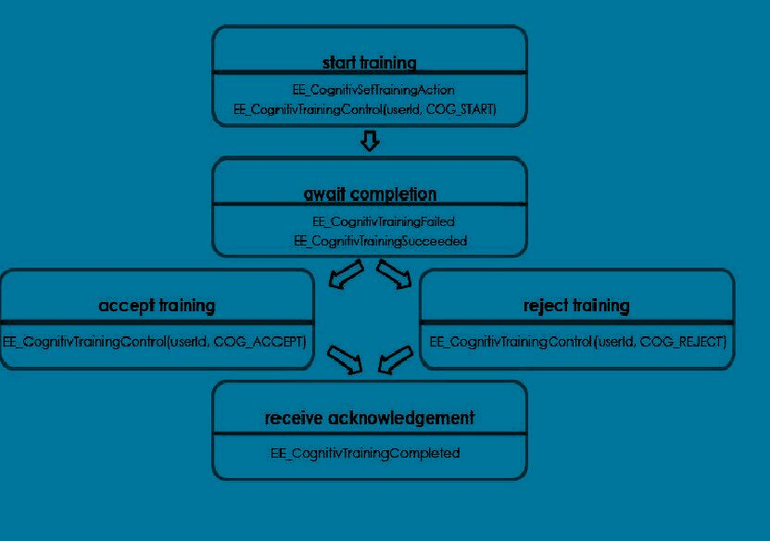

- This sort of training is usually called Cognitive Training, where Data from training to classify their individual brainwave ‘signature’, for each focussed and intent thought trained.
- There are four different mental states or facial gesture and predefined Actions that can be triggered when they occur.

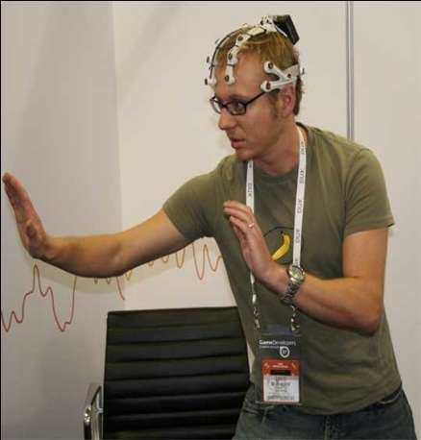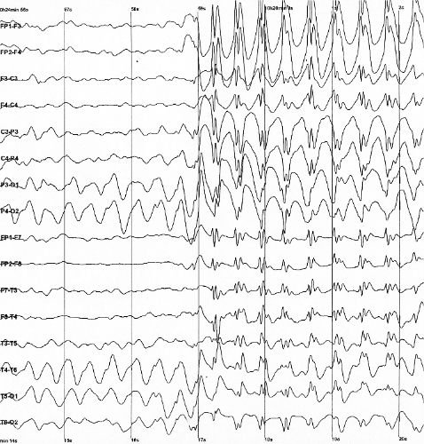

6. Application
6.1 Overview
Along with the headset Emotiv has provided a game to experience the magic. The game involves a first person view of the user walking around a virtual environment, with many different activities at different locations. The sky changes color according to the mood of the player. Demonstrated activities in the game include pushing and rotating giant stone structures into the shape of stone henge, then raising a temple from below the ground; levitating a large rock and some smaller ones; repairing a bridge; bending a tree; and scaring away glowing spirits with scary facial expressions.
6.2 Playing the game

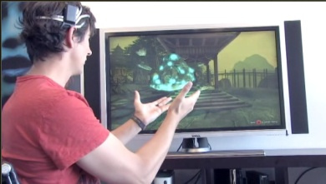
Fig. 6.1 a user is playing the game [4]

When we practice facial expressions with the game, this face on the screen imitates whatever face we are making. Whenever we are frustrated, our mind emits a particular pattern of brain waves. We can control the objects in the game just by moving our body as shown in the figure 6.1. While the pattern might stay consistent, it's probably a little different from the pattern another person emits whenever he or she gets frustrated. Because all brains are unique, the Emotiv EPOC has to get to know our brain before we can get our game on.
First, as we are putting on the headset, we need to finagle the electrodes to make appropriate contact with our head. Because it doesn't use the adhesive material of medical electroencephalogram machines and the headset is meant to fit all sizes, we need to arrange the electrodes manually until they're just right. Refrain from making jerky movements to avoid disconnecting an electrode.
In the game we are challenged to perform tasks for a sensei (means teacher). In this game, we are told to practice concentrating on a specific motion, such as lifting. The headset's electrodes record the resulting brain waves during our concentration, and from then on, the system recognizes that pattern as the lift function. Concentration is key, which can be challenging. It is recommended that we physically pantomime the motions so that we stay focused on the task at hand and are able to repeat it later in the game.
A few of the actions the game asks you to practice and perform are:
- 1.Lifting an object
- 2.Dropping an object
- 3.Pushing an object
- 4.Making an object vanish
- 5.Rotating an object on six axes
Other aspects of the EEG readings don't have to be quite so unique to us to work. For instance, the system can pick up on general boredom even if it hasn't asked the player to practice boredom before. The system recognizes that if we are emitting more theta waves than usual, we are basically zoning out. The system can respond by ramping up the excitement in the game.
Some emotions it reads are:
- Excitement, tension, boredom, immersion, meditation, frustration
Aside from actions and emotions, the headset can also read facial expressions. As we wink or frown, a corresponding cartoonish face on the screen mimics the action. This can be incorporated into the game as well.

Here are some of the actions the headset can read:
- Winking as seen in figure 6.2
- Laughing
- Crossing eyes
- Appearing shocked
- Smiling
- Getting Angry
- Smirking
- Grimacing

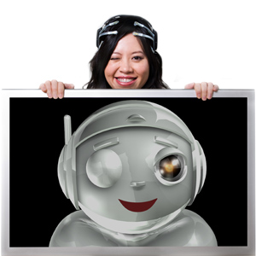
Fig.6.2. an avatar blinking just like the person

6.3 More Applications
Some applications are provided to the users whish can be downloaded from the Emotiv’s website.
- Photos:
We can view our photos as well as modify them just by thinking. We can change the brightness, intensity of colors and so on.

- Tools: (emotive epoc brain activity map)
This application displays a real-time map of our mental activity in four significant brainwave frequency bands. Adjustable gain allows us to see detailed information and relative strengths between different brain regions.
- Games:
To increase the skills of using the Emotiv Epoc these games are provided. So the headset gets used to our brain waves. The games are Cortex Arcade and Spirit Mountain Game
- NeuroKey:
NeuroKey is a Windows compatible application that enables the wearer of an Emotiv EEG Headset to emulate a PC keyboard using head and facial movements, as well as pure thoughts.
- Developer tools:
NeuroVault is a high performance digital data recorder which captures data from the Emotiv EEG Headset and combines it with data from a variety of other sources. All data is synchronised so that during playback we can review EEG readings, in 200ms intervals, with its associated audio, video data. The professional version, due Jan/Feb, will include many additional features including recording and playback of all cognitive events and raw EEG data. For example, a game developer would use NeuroVault to capture a gamer putting a new game through its paces. Afterwards, he could playback synchronized video, audio and EEG data, and see immediately which events in the game excited the player, or were frustrating, challenging or just downright boring. Because NeuroVault lets you review the data at your leisure, it’s very easy to visualise the exact events which trigger changes in emotional state.

7. Developer applications

7.1 Implications of Thought-Controlled Games
If the EEG gaming technology eventually catches on, it could revolutionize the way people think about video games. On the one hand, with its facial expression interpretations, the Emotiv EPOC attempts to close the gap further between the real world and the virtual world to create a more realistic experience. On the other hand, the Emotiv EPOC also tries to bridge the gap between human thought and the outside world to create an experience that's less like reality and more fantastical and dreamlike. The technology behind EPOC eliminates the middleman of motion altogether -- a staggering thought to consider.
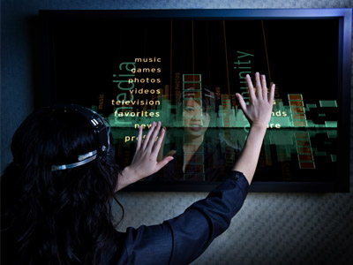
Fig 7.1 Other uses of Emotiv Epoc

One idea is that people would be able to experience realistic virtual training with the Emotiv technology. Time will tell if the EPOC and similar technology will extend beyond the gaming market or even permeate the gaming world at all.
Though there are certainly plenty of gamers who are excited to usher in an age of thought-controlled video games and interfaces, there are others who find the whole idea, and even the experience of playing it, "unnerving". Some question the possible harmful applications of such devices. Should researchers continue making more breakthroughs to advance EEG technology, it could plausibly lead to computers that can, in essence, read someone's mind. Those with the technology could be privy to the private thoughts, opinions and emotions of others. Granted, this could be very far off, considering where the technology (and our understanding of the human brain) is now. Nevertheless, we can't rule out the possibility entirely.

7.2 Few trial Applications:

7.2.1 Two of the best known developer applications of the Emotiv Epoc are: The brain driver car and the mind controlled wheel chair
7.2.2In the brain driver car the can be made to accelerate/decelerate or turn just by bio-electric signals from the 16 channel EPOC
7.2.3An electric wheel chair can be made to navigate just by simple actions such as blinking and smiling.
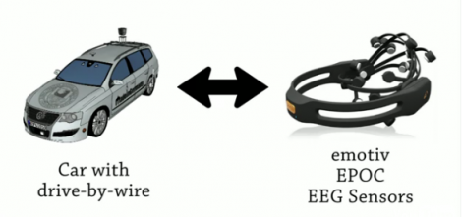
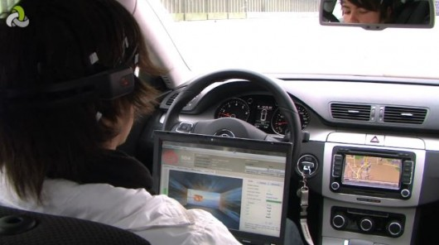
7.2.1 Car driven by Epoc headset
8.Conclusion
The Emotiv Epoc is a very powerful tool in the world of mind-controlled processes. It is easy to use and wireless. The portability provides a better usage of the headset. The technology used to detect the motion as well as human expressions is very effective. It is possible to analyze the brain waves on our own as corresponding software is also provided. We can develop our own application which can be used with the headset.
The game provided with the headset is used to enhance the capturing ability of the headset. The headset can be used by more than one person (one at a time) as its detection capabilities are flexible. The headset is capable of detecting considerable amount of expressions and emotions.
It is necessary to spend some time using the headset as it takes some time to skillfully handle it. It is very useful as we can control the things not by our body but our mind.
The base of emotiv epoc is brain computer interface (BCI) which is as follows:
- Brain-Computer Interface (BCI) is a method of communication based on voluntary neural activity generated by the brain and independent of its normal output pathways of peripheral nerves and muscles.
- The neural activity used in BCI can be recorded using invasive or non-invasive techniques.
- We can say as detection techniques and experimental designs improve, the BCI will improve as well and would provide wealth alternatives for individuals to interact with their environment.
- Electroencephalography is the process of recording the electrical activity in the brain.
Emotiv Epoc is a neural headset that works on the principle of Electroencephalography or EEG.

9.REFERENCES
1. “Measuring Subjectivity”-Supporting Evaluations with the Emotiv EPOC Neuroheadset
Daniel Cernea , Peter-Scott Olech, Achim Ebert,Andreas Kerren( 19 January 2012)
2. Towards Brain First-Aid: A Diagnostic Device for Conscious Awareness
Ryan C. N. D’Arcy, Sujoy Ghosh Hajra, Member, IEEE, Careesa Liu, Member, IEEE,
Lauren D. Sculthorpe, and Donald F. Weaver(3 March 2011)
3. Head movements based control of an intelligent wheelchair in an indoor environment
Ericka Janet Rechy-Ramirez, Huosheng Hu and Klaus McDonald-Maier(11 December 2012)
4. Choice modeling and the brain: A study on the Electroencephalogram (EEG) of preferences
Rami N. Khushaba , Luke Greenacre , Sarath Kodagoda , Jordan Louviere , Sandra Burke ,
Gamini Dissanayake(9 September 2012).
5. Restoration of Whole Body Movement-Toward a Noninvasive Brain–Machine Interface System
By José L. Contreras-Vidal, Alessandro Presacco, Harshavardhan Agashe, and Andrew Paek (6 February 2012)
6. www.emotive.com

